Get all manager

<http://localhost:8080/managers/getAllManagers>

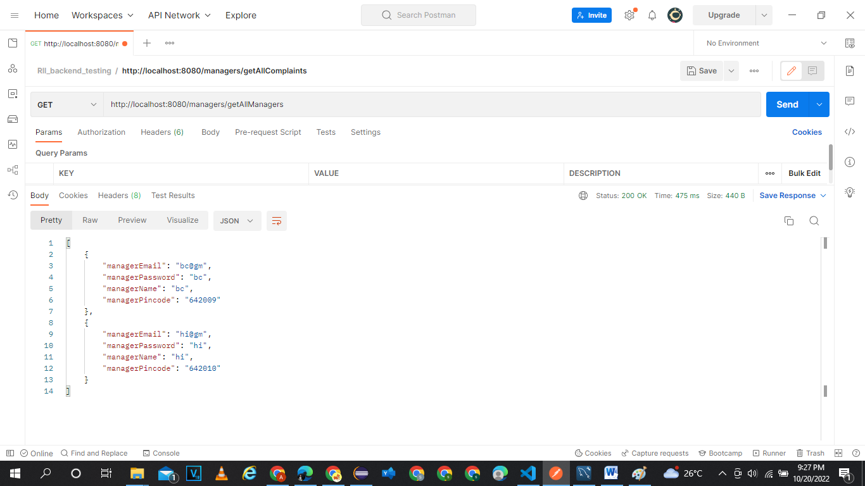

Add new manager:

http://localhost:8080/managers/addManager

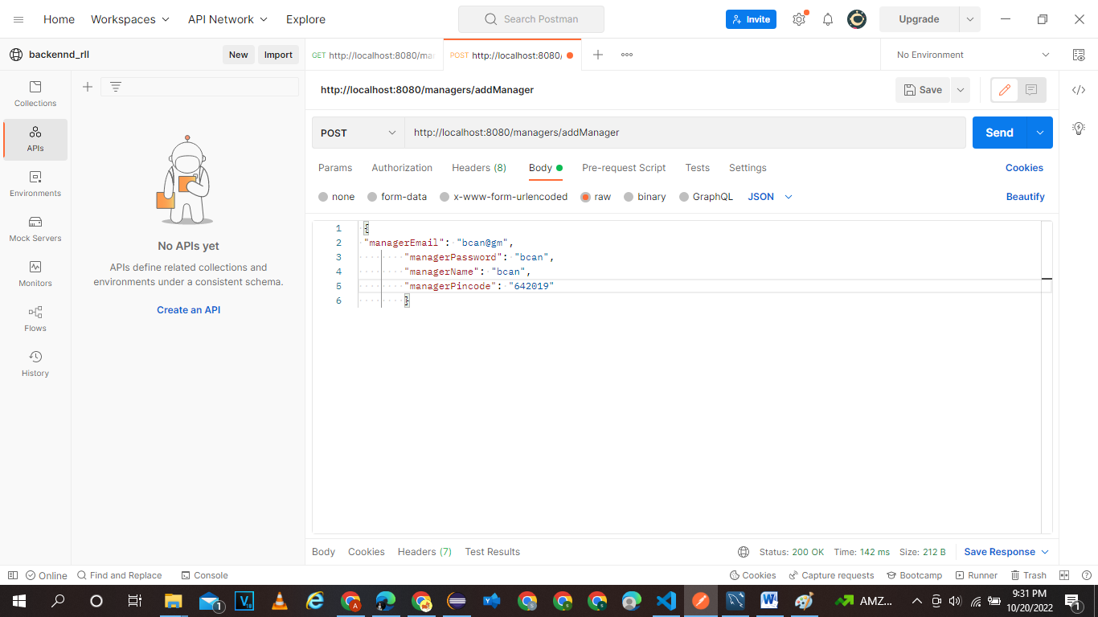

Login as manager

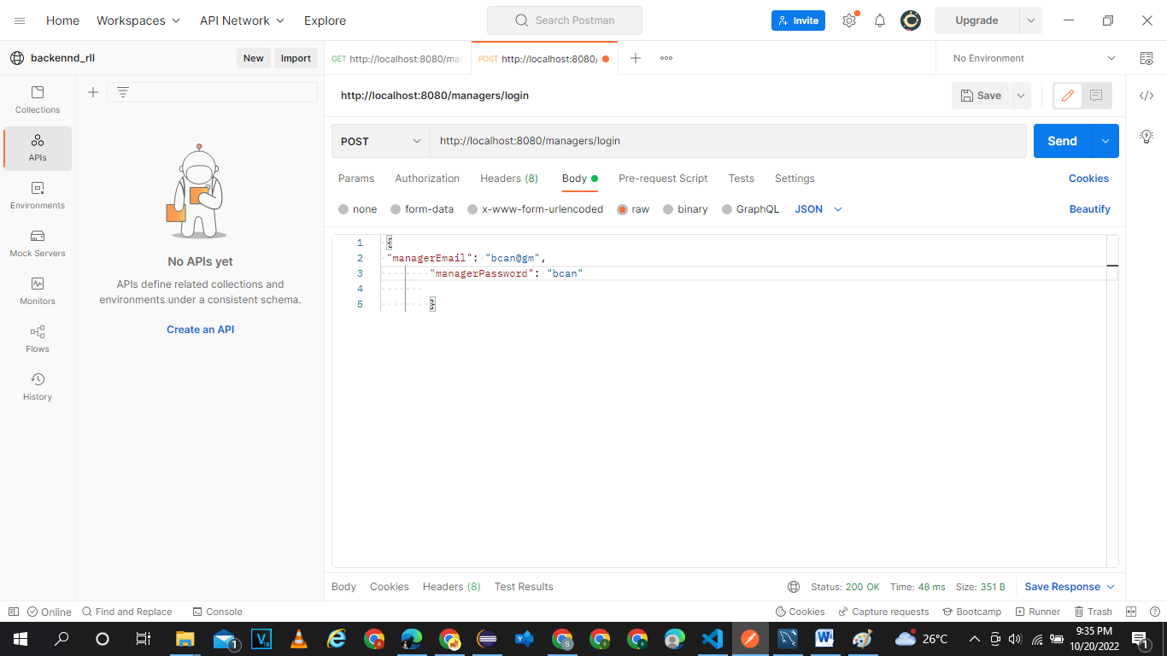

Delete manger-through mailid

http://localhost:8080/managers/deleteManager/bcan@gm

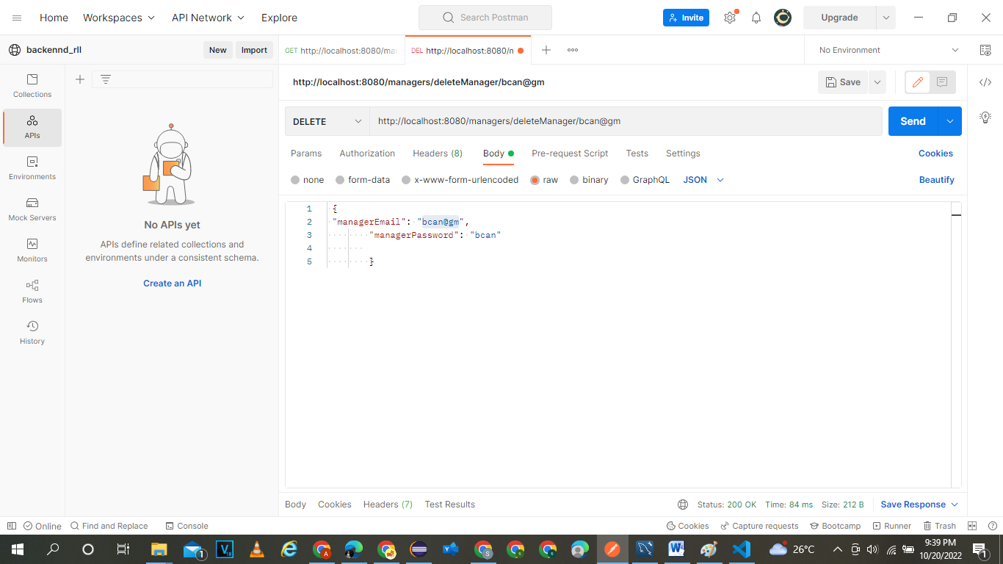

Get all Customer:

http://localhost:8080/customers/getAllCustomers

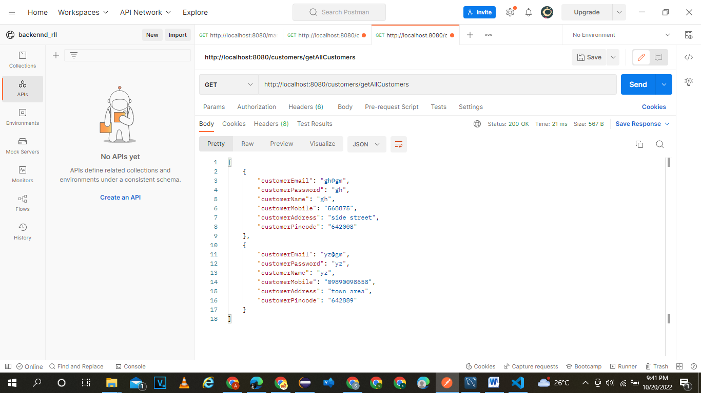

Login as customer

http://localhost:8080/customers/login

 {"customerEmail": "gh@gm",

        "customerPassword": "gh"}

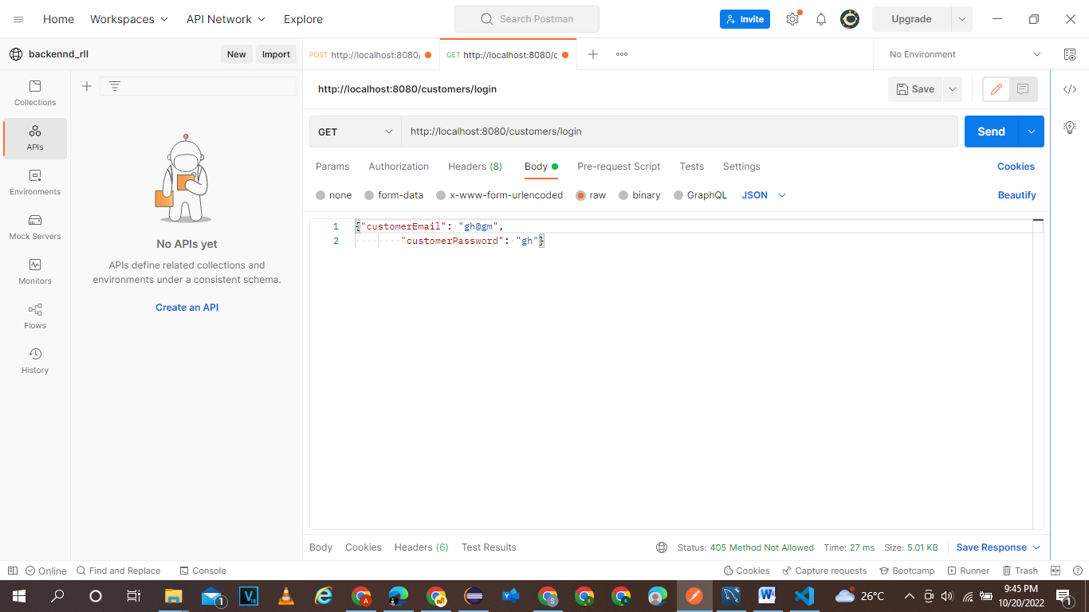

Add customer

<http://localhost:8080/customers/addCustomer>

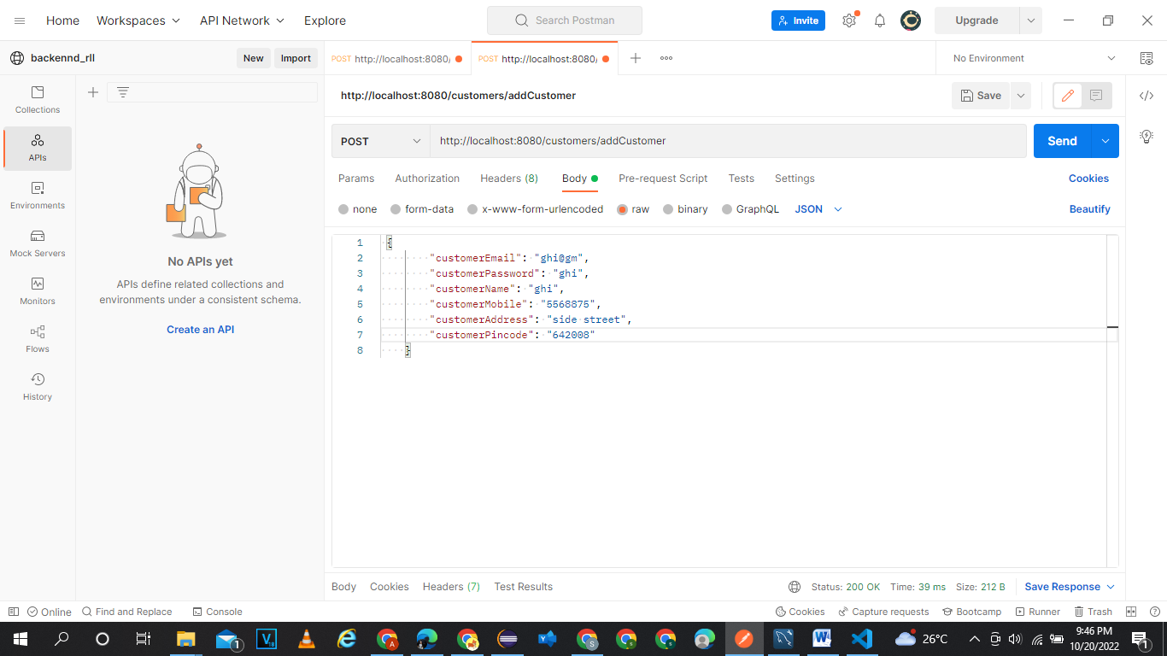

{

        "customerEmail": "ghi@gm",

        "customerPassword": "ghi",

        "customerName": "ghi",

        "customerMobile": "5568875",

        "customerAddress": "side street",

        "customerPincode": "642008"

    }

Delete an customer

<http://localhost:8080/customers/deleteCustomer/ghi@gm>

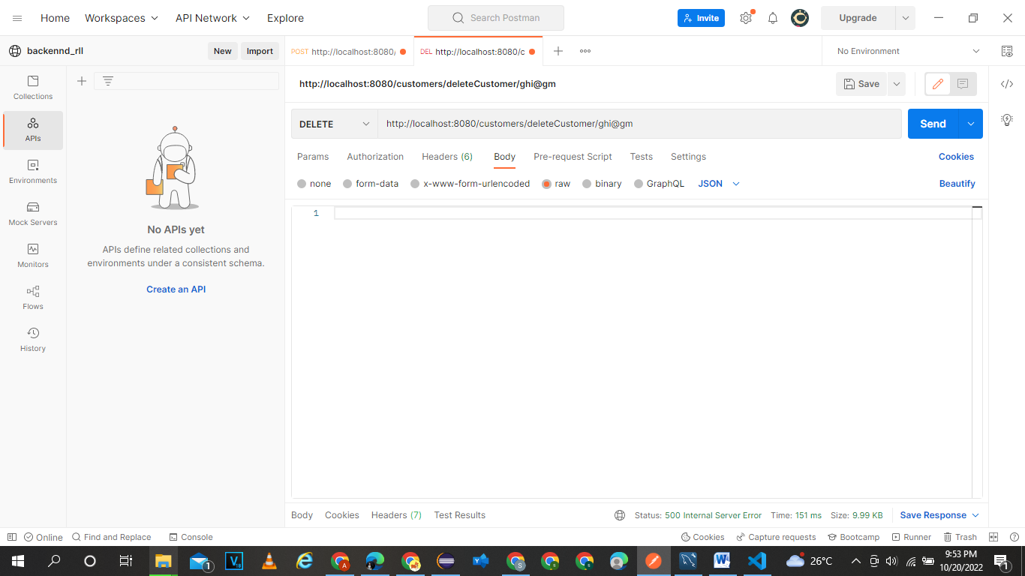

Get all complaints:

<http://localhost:8080/complaints/getAllComplaints>

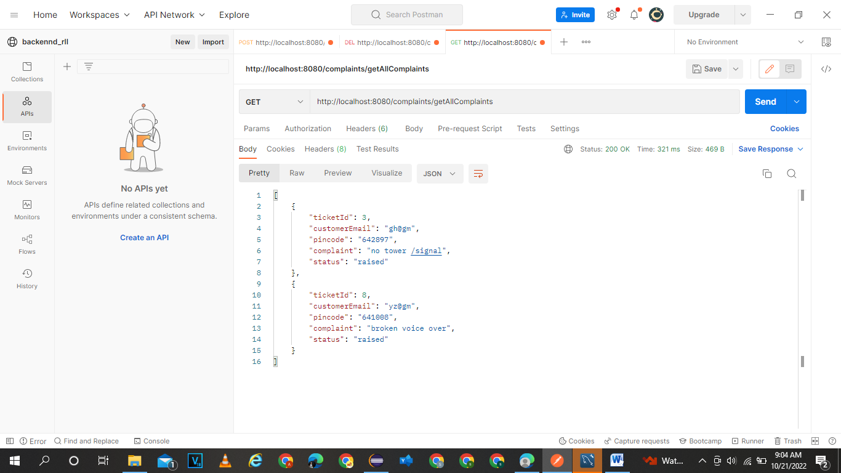

Get by customer mails:

<http://localhost:8080/complaints/getAllComplaintsByEmail/gh@gm>

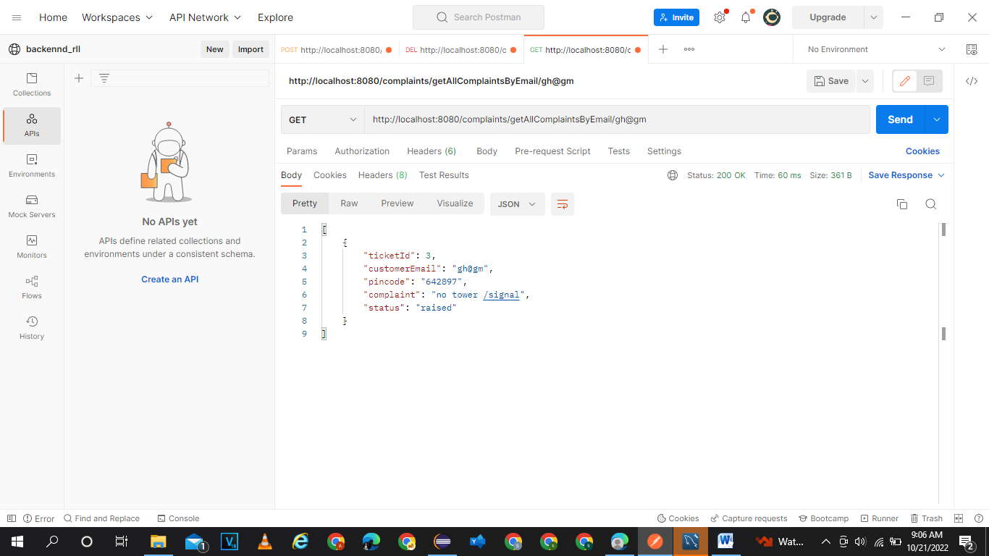

Get complaint by ticket id:

<http://localhost:8080/complaints/getComplaintById/3>

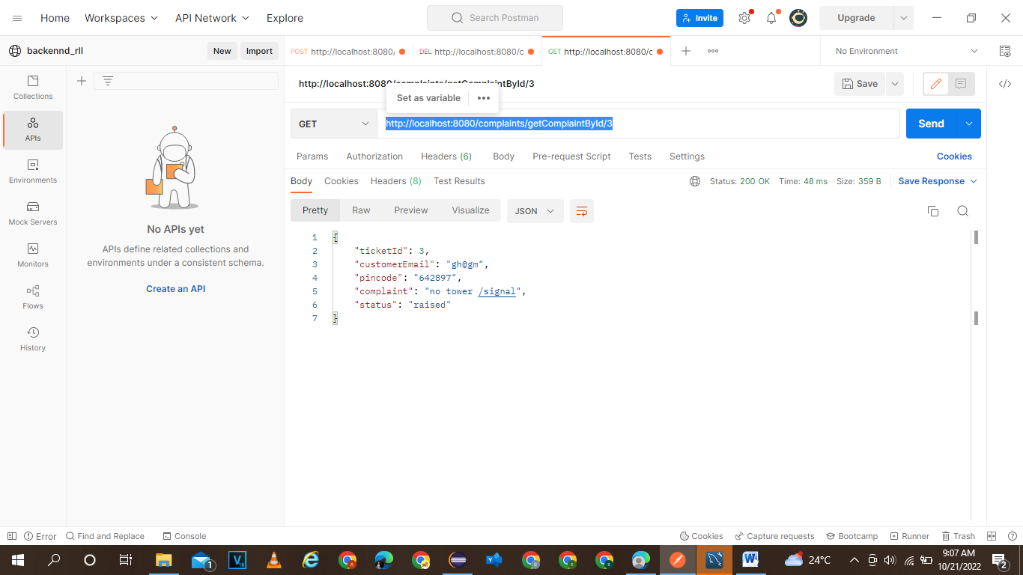

Addcomplaints:

<http://localhost:8080/complaints/addComplaint>

{

    "ticketId": 7,

    "customerEmail": "ghhe@gm",

    "pincode": "642897",

    "complaint": "no tower /signal",

    "status": "raised"

}

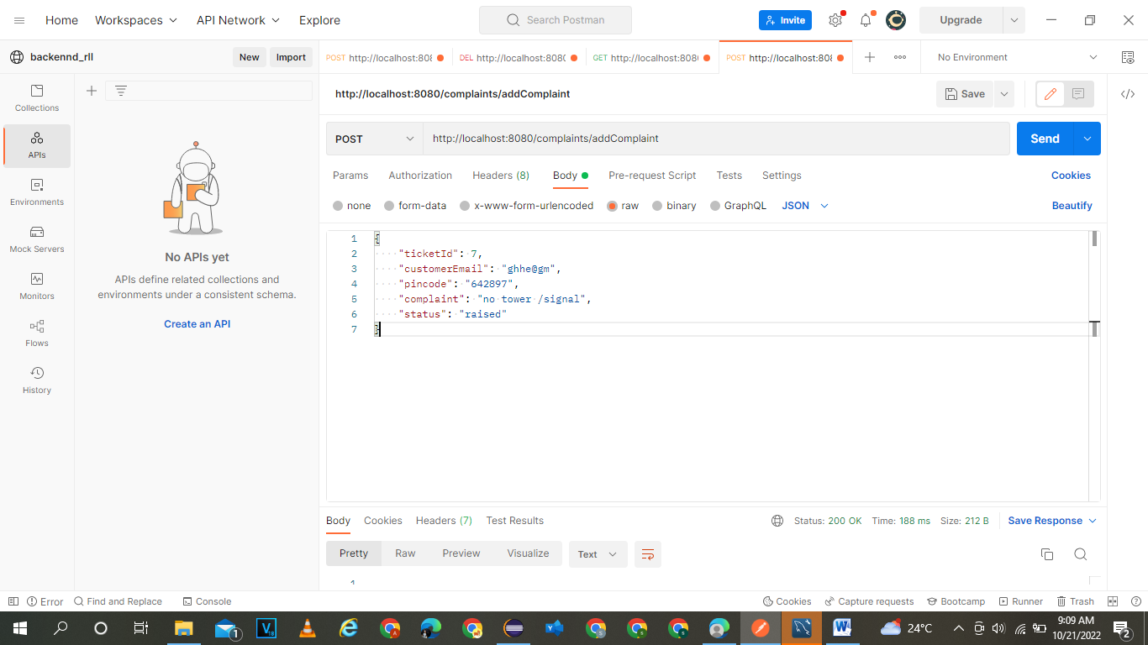

deletebyId:

<http://localhost:8080/complaints/deleteComplaintById/7>

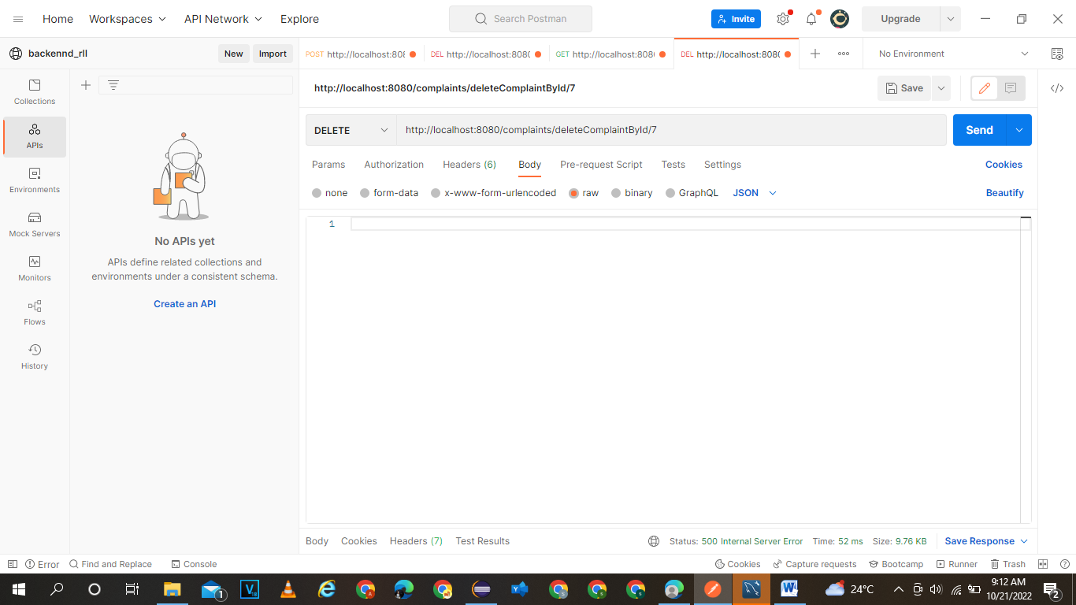

Getallfeedbacks:

<http://localhost:8080/feedbacks/getAllFeedbacks>

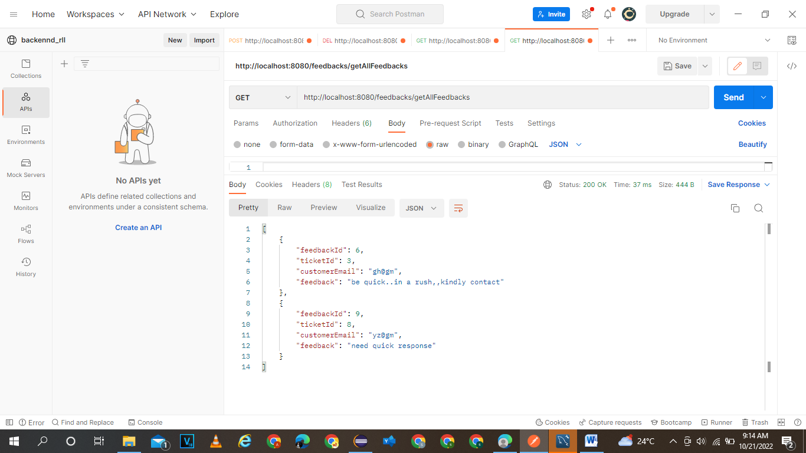

Add feedback:

<http://localhost:8080/feedbacks/addFeedback>

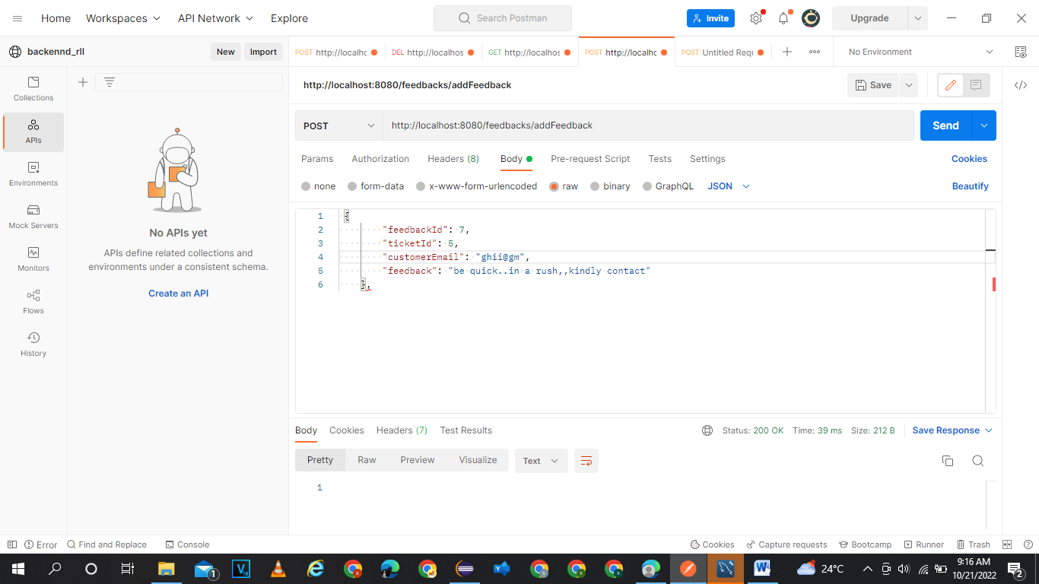

Get all engineers

<http://localhost:8080/engineers/getAllEngineers>

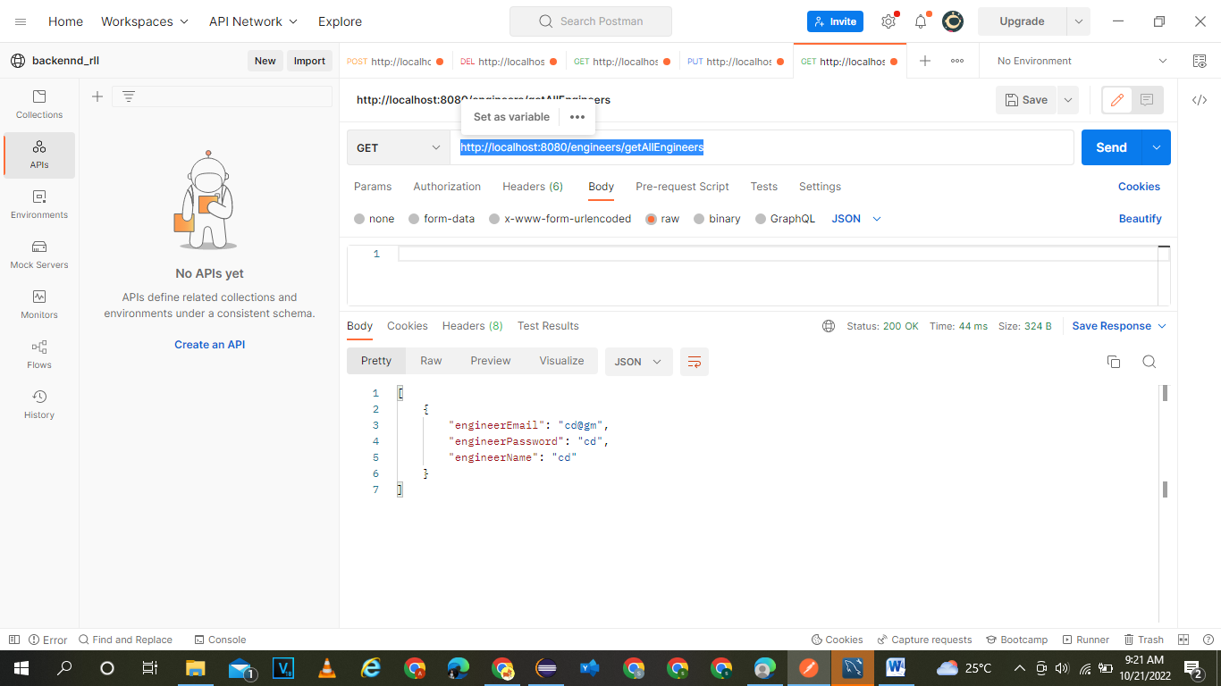

Get all enginner by mail:

<http://localhost:8080/engineers/getAllEngineerMails>

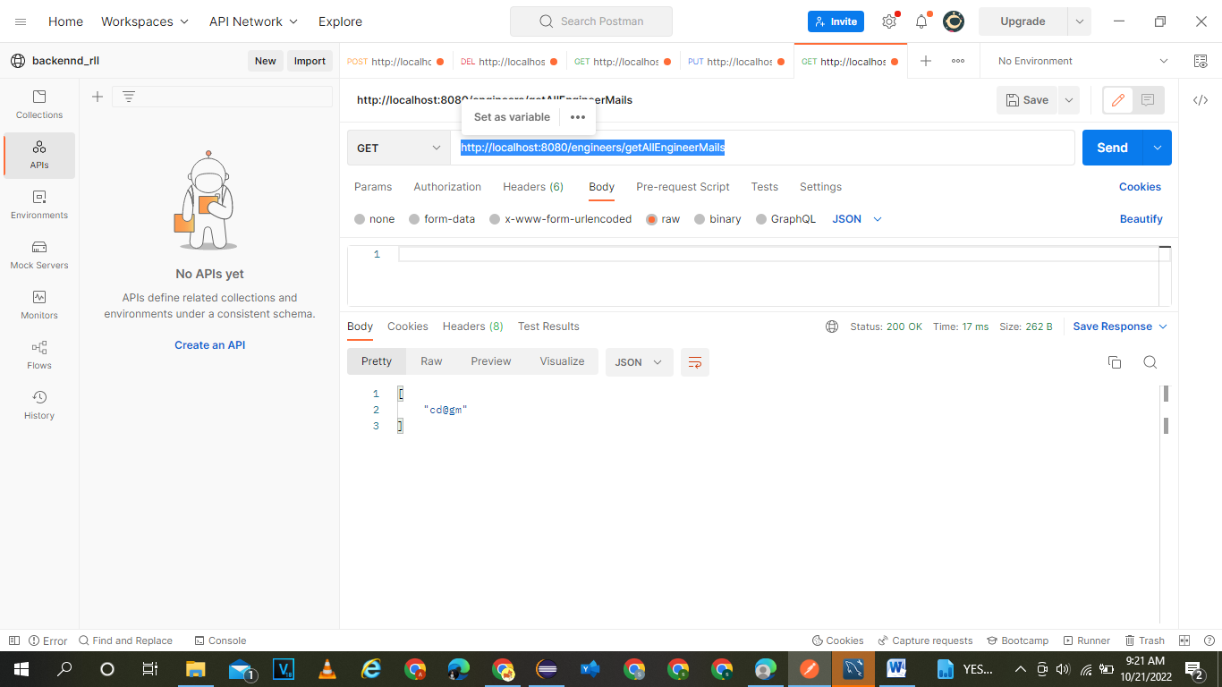

Add engineer

<http://localhost:8080/engineers/addEngineer>

